Here are few quick steps to push your projects from local desktop to Github:

1. Download Github desktop application on your PC.
2.If you are already have a Github account then sign in but in case of new user,sign up to your desktop application.
3.After signing in the application you can see the following screen:
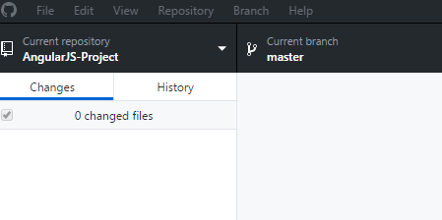

4.Go to File Menu → Choose add local repository among the options to see the following screen.


5.Now navigate to the location of the project by clicking on choose option.

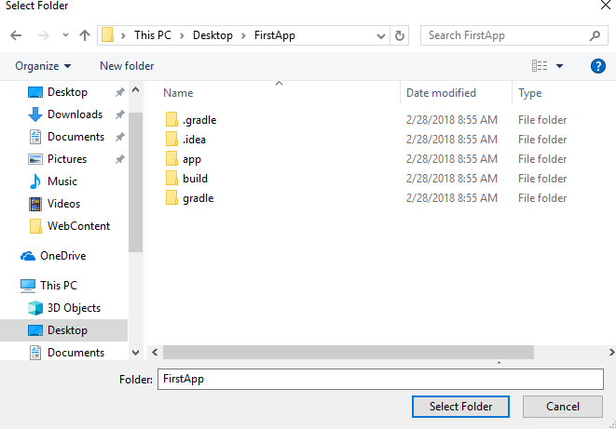

6. Now click on Select the Folder button then you will see the following screen:


7.Now click on create a repository highlighted text. Then it will show the following screen:

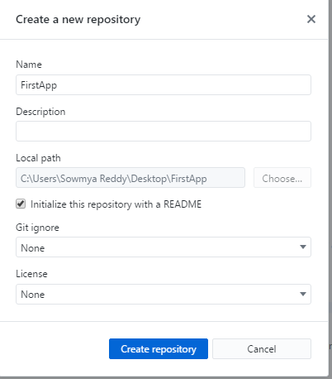

8.Click on Create repository button to see the following screen.
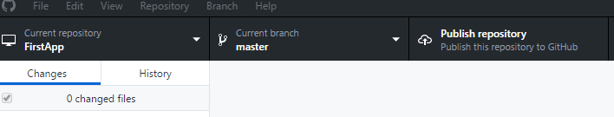

9. Select Publish repository tab on the right to see the following screen.

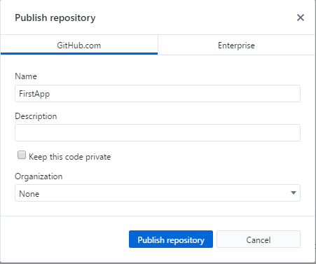

10.Click on the Publish Repository button to view the following screen.



11.This indicates that the project is pushed to the Github repository from the local desktop.

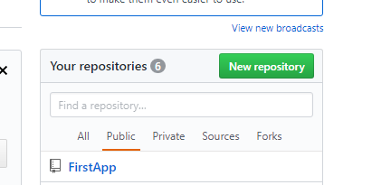

Note: There are many methods to upload projects to Github and this is one of the best methods I found to be helpful by not using Command Prompt.

